**1.Introduction**

* 1. **Overview**

Financial performance analysis describes the methods that those examining affairs of a business use to evaluate and assess its financial activity. Financial performance refers to the overall financial health of the business. Analyzing financial performance is the process of evaluating the common parts of financial statements to obtain a better understanding of firms position and performance. Financial performance analysis enables the investors and creditors evaluate past and current performance and financial position, and to predict future performance. Financial statement is used to judge the profitability and financial soundness of a firm.

Financial performance is the selection, evaluation, and interpretation of financial data, along with other pertinent information, to assist in investment and interpretation of financial decision-making. Financial analysis may be used internally to evaluate issues such as employee performance, the efficiency of operations and credit policies and externally to evaluate potentials investments and the credit worthiness of borrowers, among other things.

The analysis draws the financial data needed in financial from many sources. The primary source is the data provided by the firm itself in its annual report and required disclosures. The annual report and required disclosures. The income statement, the balance sheet, and the statement of cash flows, as well as to these close statements certain business required by securities laws to disclose addition anal information.

Besides information that companies are required financial statements, other information is ready available for financial analysis for example information such as the market prices of security of publically –trades corporations can be found in the financial press on the electronics media daily. Similarly, information on stock price indicates for industries for industries and for the market as a whole as available in the financial press.

**1.2 purpose**

Financial analysis plays a crucial role in the success of businesses by providing insights into a company's financial health. Financial statement analysis is a key component of financial analysis that enables businesses to evaluate their financial performance, identify areas for improvement, and make informed decisions. This write-up explores the importance of financial analysis for businesses, including how it helps with shares investment and holding, plans, decisions, and management, providing credit, and assessing a company's financial health. The methods of financial statement analysis, including ratio analysis, trend analysis, and comparative analysis, are also discussed in this write-up. Overall, financial analysis is a critical tool for businesses to make informed decisions, allocate resources efficiently, and achieve their financial goals.

The importance of financial statement analysis is a critical tool for businesses to evaluate their financial health. Knowing the importance of financial statement analysis that help get information on a company's financial performance, including its profitability, liquidity, solvency, and efficiency. Financial analysis enables businesses to identify trends, evaluate performance, and make informed decisions. Take a deep dive into the basics of financial markets to know more.

There are several key financial metrics that analysts use to determine the value of a business, including revenue growth, profitability, cash flow, and return on investment. These metrics enable analysts to evaluate a company's financial performance and assess its ability to generate future profits. Tools of financial statement analysis also enables businesses to compare their financial performance to that of their competitors and industry benchmarks. This analysis provides valuable insights into the company's position in the market and its competitive advantage.

**2.Problem definition and design thinking**

**2.1 Empathy map**

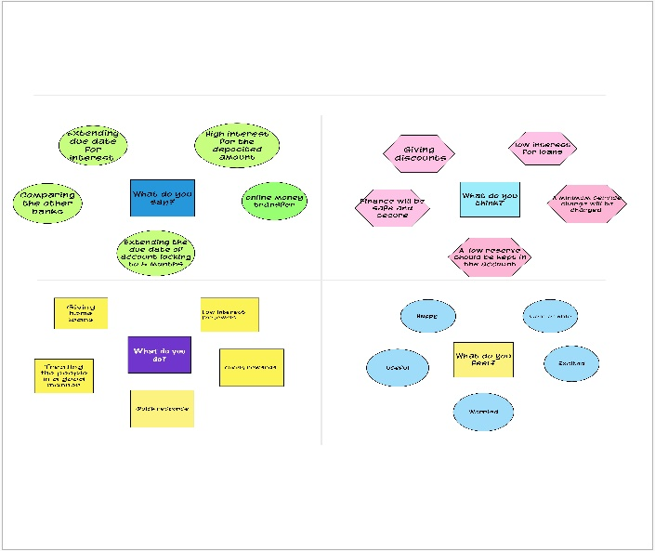

**2.2 Ideation &Brainstorming Map**



**3.Results**





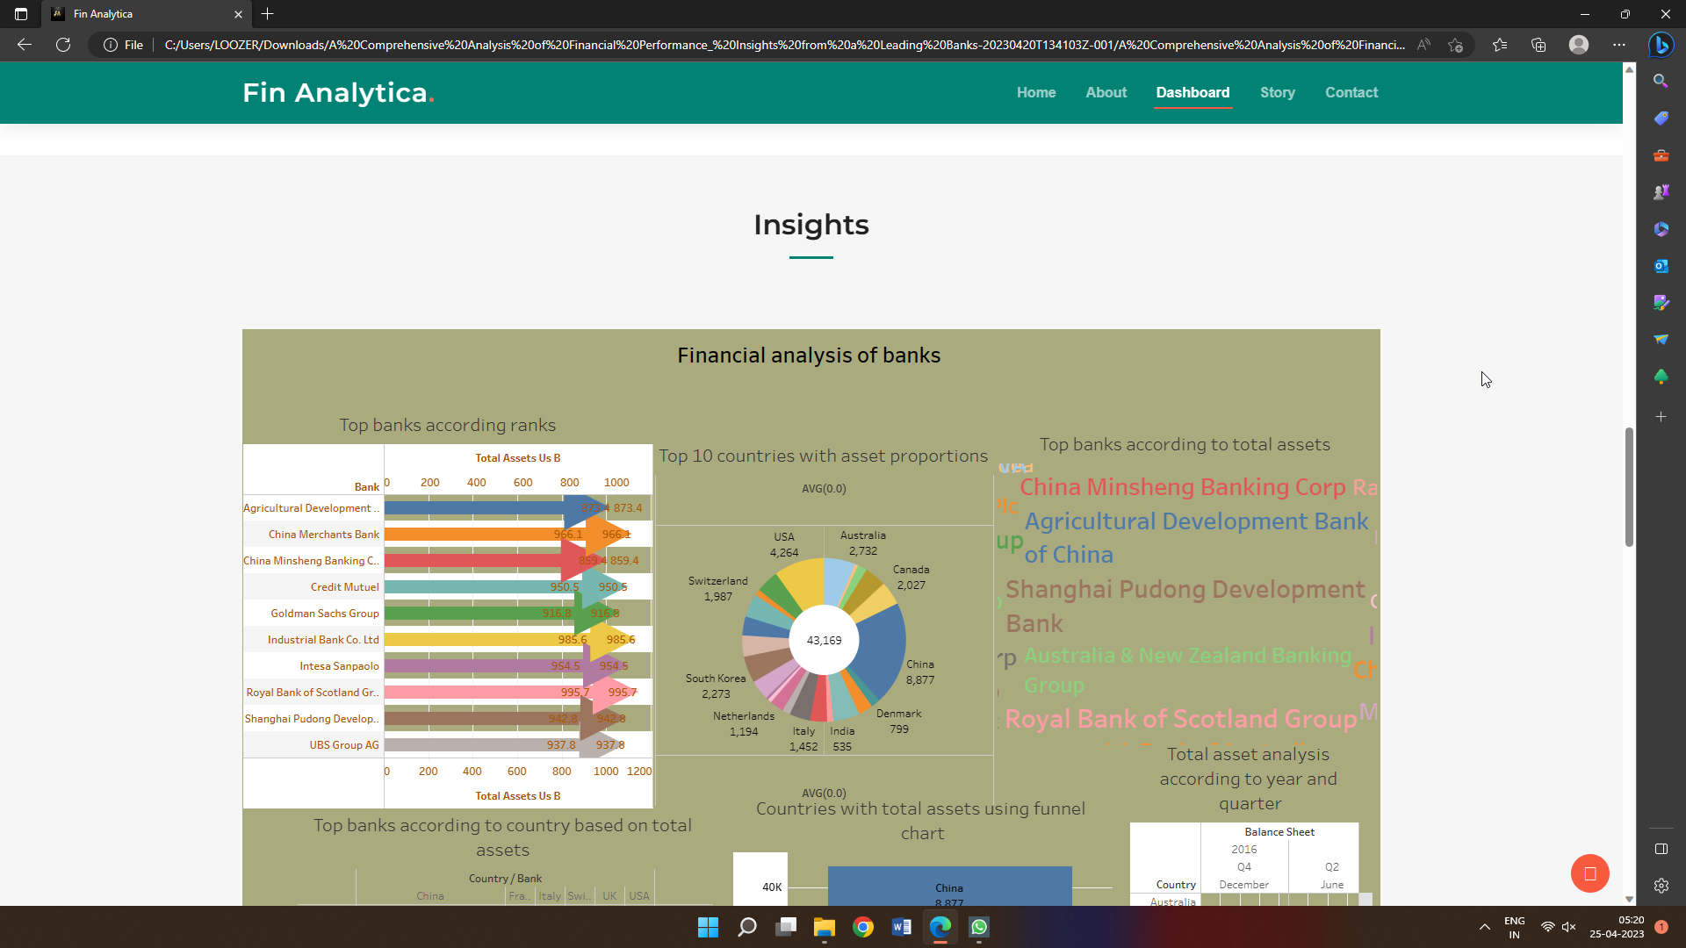

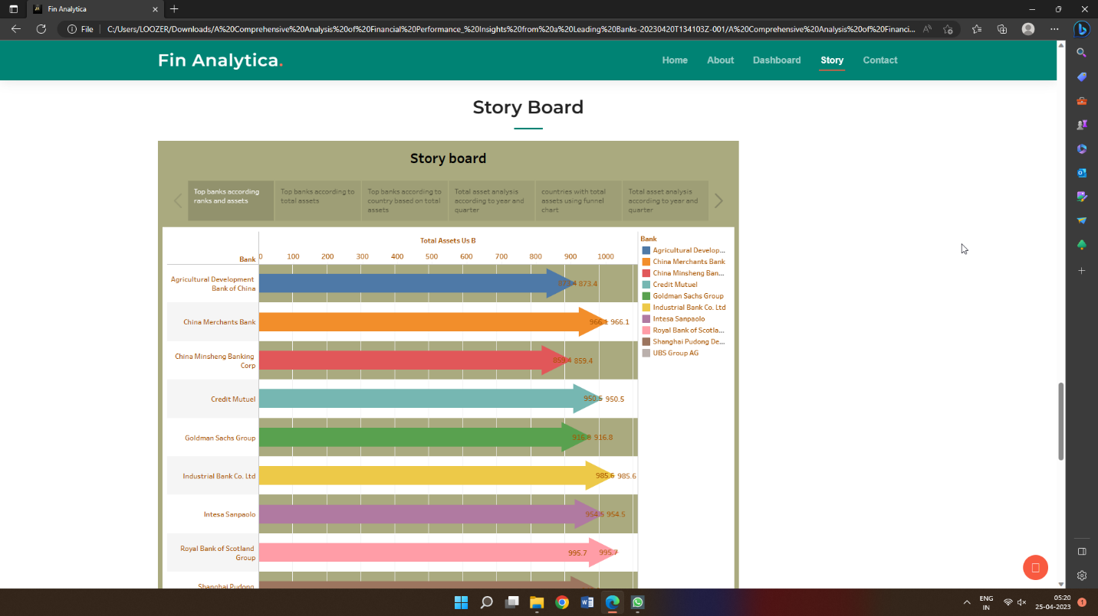

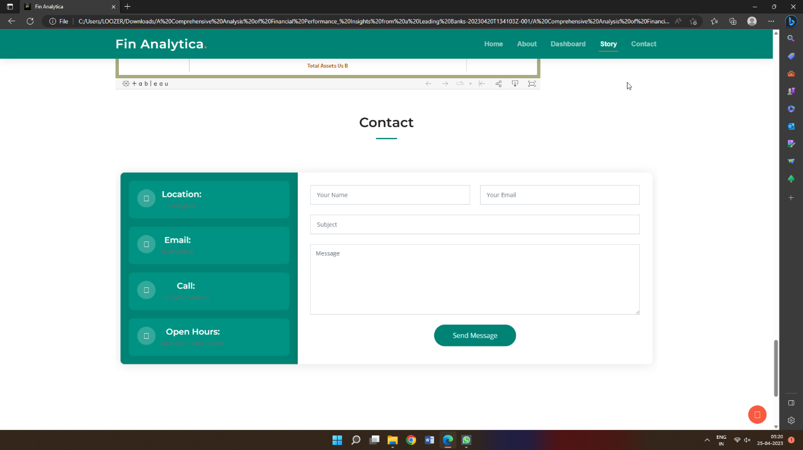

**4. Advantages & disadvantages**

**4.1 Advantages**

It makes analysis simple and fast as past figures can easily be compared with the current figures without referring to separate past Income Statements. It makes comparisons across different companies also easy and helps analyze the efficiency both at Gross Profit Level and Net Profit Level.

Safety of public saving and builds public confidence and trust.The most important benefit if financial statement analysis is that it provides an idea to the investors about deciding on investing their funds in a particular company.

Another advantage of financial statement analysis is that regulatory authorities like IASB can ensure the company following the required accounting standards. Financial statement analysis is helpful to the government agencies in analyzing the taxation owed to the firm.

**4.2 Disadvantages**

The financial analysis does not contemplate cost price level changes. The financial analysis might be ambiguous without the prior knowledge of the changes in accounting procedure followed by an enterprise.

The financial analysis does not contemplate cost price level changes. The financial analysis might be ambiguous without the prior knowledge of the changes in accounting procedure followed by an enterprise.

**5.Applications**

1. Investment Management: Financial analysis of world banks can help

investment managers to identify potential investment opportunities and

make informed decisions about their investments in the banking sector.

2. Regulatory Compliance: Financial analysis can help banks to comply

with regulatory requirements and maintain regulatory standards.

3. Risk Management: Financial analysis can help banks to identify potential

risks and develop strategies to manage them effectively.

4. Strategic Planning: Financial analysis can provide valuable insights into

the financial health, profitability, and overall performance of banks,

which can inform strategic decisions and help banks to plan for the

future.

5. Competitive Analysis: Financial analysis can be used to compare the

financial performance of different banks, identify industry best practices,

and set benchmarks for performance.

**6.Conclusion**

The analysis involved collecting and importing financial data from

various sources into Tableau, cleaning and transforming the data, and creating

interactive dashboards and visualizations to explore different aspects of the

data. The analysis also used advanced features of Tableau, such as forecasting

and machine learning, to identify patterns and trends in the financial data and

predict future performance of the banks.

The findings of the analysis provided valuable insights into the financial

performance of different banks, identifying areas of strength and weakness,

potential risks, and opportunities. The analysis also allowed for benchmarking

and comparison of the financial performance of different banks, which can

inform industry best practices and set benchmarks for performance.

**7.Future scope**

1. Integration of External Data Sources: Integration of external data sources,

such as social media, news feeds, and economic indicators, can provide a

more comprehensive view of the banking industry and help to identify

emerging trends and risks.

2. Incorporation of Environmental, Social, and Governance (ESG) Metrics:

The incorporation of ESG metrics can provide stakeholders with insights

into the social and environmental impact of banks, enabling them to make

more sustainable and responsible investment decisions.

3. Cross-Industry Analysis: Cross-industry analysis, such as comparing the

financial performance of banks with other industries, can provide

valuable insights into the overall economic landscape and help to identify

potential opportunities and risks.

4. Real-time Reporting: Real-time reporting can provide stakeholders with

up-to-date information on the financial performance of banks, enabling

them to make timely and informed decisions.

**8.Appendix**

**8.1 HTML code for the output web page**







